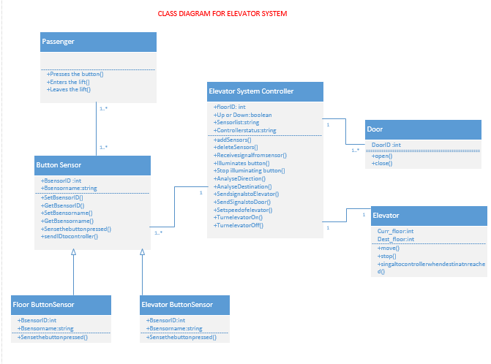

1.)class diagram for elevator system

**Classes Taken:**

**Passenger**: This refers to the user of the elevator. The operations that the user performs are he or she presses the lift button, enters the lift when door is opened and gets out of the lift when door is closed.

The passesger has an association relationship with the button interface.

**Button Sensor**: This senses when the button is pressed and passes the information to the elevator system controller that which button is pressed.This has two sub classes :

1)floor buttonsensor: Senses the button if any floor button is pressed.

2)elevator buttonsensor:senses the button if any button inside the lift is pressed.

So, the relation between the sub classes and super class is called inheritance relation or generalization.

**Elevator System Controller:** This is the heart of the elevator system. It performs many actions for the efficient working of the elevator.This adds and removes sensors of the buttons. And it identifies the signal from the sensors It takes care of illuminating the button, Analyzing the direction of the lift, Sending signals to elevator to move and doors to open. The fundamental operation of the elevator lies within elevator system controller.

**Door:** It is responsible for opening and closing the door.

**Elevator**: This class gives motion to the elevator.

**Relations and Multiplicity:**

Passenger –Button sensor: we have association relation between these two and we have number of passengers and number of buttons.so multiplicity is one or many on both sides

Buttonsensor –floorbuttonsensor ,Buttonsensor-elevatorbuttonsensor: These both are inheritance relations where buttonsensor class is parent class.

Elevatorsystemcontroller-Button sensor:Here we have association relation. We only have one elevator system but we have one or many button sensors involved at a time in this relation.

Elevatorsystemcontroller-Door: Here we have association relation. We only have one elevator system but we have one or many doors involved at a time in this relation.

Elevatorsystemcontroller-Elevator: Here we have association relation. We only have one elevator system but we have one or many elevator involved at a time in this relation.

2)SEQUENCE DIAGRAM:

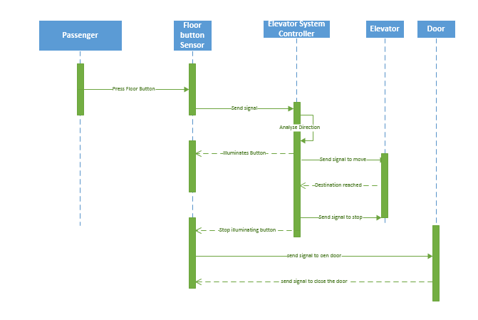

**Sequence Diagram Description**: It is an interaction diagram which describes the interaction of one class with other with respect to time.

**This is the sequence diagram pertaining to the floor:**

-First of all the passenger presses the floor button

-This will be recognized by the floor button sensor where it informs to the button sensor

-The button sensor send signal to the elevator control system sending its ID.

-The elevator control system analyses the direction

-It illuminates the lightat button

-elevator control system gives signal to the elevator to move.

-Which informs the control system when destination is reached.

-Then it signals it to stop

-and turns of the light at the button pressed.

-elevator control system sends signal to door to open

-after some time it sends signal to close the door.

3) ARCHITECTURE DIAGRAM:

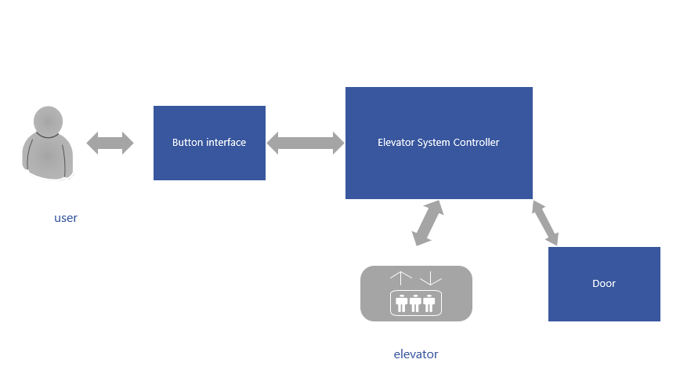Architecture Diagram Description:

Here the passenger interacts with the button interface.

The button interface interacts with elevator system control which gives instruction to the doors and elevator.

The elevator system controller controls the whole process of the elevator.It is the heart of the elevator management system.